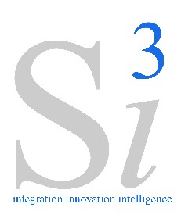 | 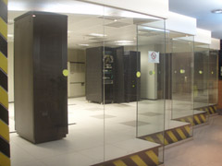 | 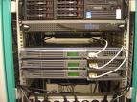
Si3 – Data Center Hosting
Services
About Si3
Si3 is one of Pakistan's Premier IT Systems Integrator with capacity and experience for providing strategic technology solutions that achieve real business results for businesses in diverse industries including Financial Services, Logistics, Telecommunications, Oil & Gas, Defense, and the Public Sector. Si3 professionals along with alliance partners provide an unmatched level of domain expertise with a results-oriented approach. The Company delivers business value using IT to empower organizations with innovative and scalable technology solutions that increase their competitive advantage and return on investment.

W hy Data Center Hosting Services  IT operations are a crucial aspect of most organizational operations. One of the main concerns is business continuity; companies rely on their information systems to run their operations. If a system becomes unavailable, company operations may be impaired or stopped completely. It is necessary to provide a reliable infrastructure for IT operations, in order to minimize any chance of disruption. Information security is also a concern, and for this reason a data center has to offer a secure environment which minimizes the chances of a security breach.  A data center must therefore keep high standards for assuring the integrity and functionality of its hosted IT environment. | Salient Features of Si3 Data Centers  At Si3, a team of experienced professionals of Data Centers is available to render the requisite services for your organization. The Salient features of Si3’s Data Center Hosting Services include:  - High Availability 24 x 7 x 365.  - Robust Electrical Power Infrastructure (EPI).  - DR Sites at Karachi and Islamabad which may act as a back-up to each other.  - Network Security Services.  - Backup Generator for secure power supply.  - Service Level Agreements.  - Firewall.  - Remote desktop. |  | 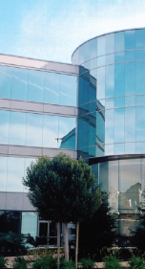
W hat We Offers at Our Data Centers  Si3 being the only System Integrator (SI) in the Country with two established Data Centers at Karachi and Islamabad, as part of our Data Center Hosting services, we offers double-redundancy DR services to organizations. Organizations may utilize one specific Si3 Data Center (e.g. at Karachi) as the primary site for normal operations while another Si3 Data Center (e.g. at Islamabad) can be utilized as a DR site.  We offers following option of Rack Servers hosting at both of our Data Centers.  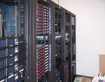  - Fully Populated Servers in a Rack.  - Half Populated Servers in a Rack.  - Servers hosting with respect to their form factor in a Rack. |  | W hat Kind of Services We offer at Our Data Centers  To provide unmatched services IBM Tivoli Monitoring (ITM) has been deployed to monitor and manage the hosted servers at our Data Center.  We offers the following services to manage the Data Center hosted equipment.  Managed Services:  - Hosted Servers are managed by our Data Center team.  - We will render 24 x 7 x 365 support to hosted Servers.  - Our Data Center engineers provides Warm and Hot Backup Facility, flexible to your backup schedule.  Un-Managed Services:  - Sitting arrangement for client  representative.  - Telephone and computer facility for client representative |  | 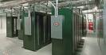  For more information on this services, please contact:    System Innovations (Pvt) Ltd.  First Floor, State Life Building  No. 1B, I.I. Chundrigar Road , Karachi 74000,  Pakistan  UAN: 111 111 743  Fax: 021 2425357  Email: info@s-iii.com  URL: www.s-iii.com

